VISVESVARAYA TECHNOLOGICAL UNIVERSITY
“JnanaSangama”, Belgaum -590014, Karnataka.


LAB REPORT

On

ANALYSIS AND DESIGN OF ALGORITHMS (23CS4PCADA)

Submitted by

Kevin Chris Hart (1WA24CS147)

in partial fulfillment for the award of the degree of
BACHELOR OF ENGINEERING
in
COMPUTER SCIENCE AND ENGINEERING



B.M.S. COLLEGE OF ENGINEERING
(Autonomous Institution under VTU)
BENGALURU-560019
February to June 2026
CERTIFICATE

B. M. S. College of Engineering,
Bull Temple Road, Bangalore 560019
(Affiliated To Visvesvaraya Technological University, Belgaum)
Department of Computer Science and Engineering



This is to certify that the Lab work entitled “ANALYSIS AND DESIGN OF ALGORITHMS” carried out by Kevin Chris Hart (1WA24CS147), who is bonafide student of B. M. S. College of Engineering. It is in partial fulfillment for the award of Bachelor of Engineering in Computer Science and Engineering of the Visvesvaraya Technological University, Belgaum during the year 2025-26. The Lab report has been approved as it satisfies the academic requirements in respect of Analysis and Design of Algorithms Lab - (23CS4PCADA) work prescribed for the said degree.

Dr. Pooja Ahuja S Dr. Kavitha Sooda
Assistant Professor Professor and Head
Department of CSE Department of CSE
BMSCE, Bengaluru BMSCE, Bengaluru

Index Sheet
Sl.  No. | Experiment Title | Page No.
1 | Write program to obtain the Topological ordering of vertices in a given digraph. | 1
2 | Implement Johnson Trotter algorithm to generate permutations. | 3
3 | Sort a given set of N integer elements using Merge Sort technique and compute its time taken. Run the program for different values of N and record the time taken to sort. | 5
4 | Sort a given set of N integer elements using Quick Sort technique and compute its time taken. | 8
5 | Sort a given set of N integer elements using Heap Sort technique and compute its time taken. | 11
6 | Implement 0/1 Knapsack problem using dynamic programming. (5 Marks) | 14
7 | Implement All Pair Shortest paths problem using Floyd’s algorithm. | 16
8 | - Find Minimum Cost Spanning Tree of a given undirected graph using Prim’s algorithm.  - Find Minimum Cost Spanning Tree of a given undirected graph using Kruskal’s algorithm. | 18
9 | Implement Fractional Knapsack using Greedy technique. | 25
10 | From a given vertex in a weighted connected graph, find shortest paths to other vertices using Dijkstra’s algorithm. | 27
11 | Implement “N-Queens Problem” using Backtracking. | 29
12 | Leetcode 268: Missing Number | 31
13 | Leetcode 1636: Sort Array By Increasing Frequency | 33
14 | Leetcode 561: Array Partition | 35
15 | Leetcode 3742: Maximum Path Scored in a Grid | 37
16 | Leetcode 70: Climbing Stairs | 39

Course outcomes:
CO1 | Analyze time complexity of algorithms using asymptotic notations.
CO2 | Apply various algorithm design techniques for the given problem.
CO3 | Evaluate the appropriate algorithm/design technique for solving a given problem.
CO4 | Conduct practical experiments by applying appropriate algorithm design technique to solve problems.

Lab program 1:
Write program to obtain the Topological ordering of vertices in a given digraph.

SOURCE CODE
#include <stdio.h>
#include <stdlib.h>
#include <time.h>

int a[20000][20000], v[20000], s[20000], top=-1, n;

void dfs(int i){
v[i]=1;
for(int j=0;j<n;j++)
if(a[i][j] && !v[j]) dfs(j);
s[++top]=i;
}

int main(){
int i,j;
printf("n: "); scanf("%d",&n);

srand(time(0));

for(i=0;i<n;i++){
for(j=0;j<n;j++){
a[i][j]=(i<j)?rand()%2000:0;
}
}

clock_t t=clock();

for(i=0;i<n;i++)
if(!v[i]) dfs(i);

printf("Topo: ");
for(i=top;i>=0;i--) printf("%d ",s[i]);

printf("\nTime: %f", (double)(clock()-t)/CLOCKS_PER_SEC);
}

OUTPUT

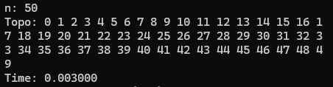

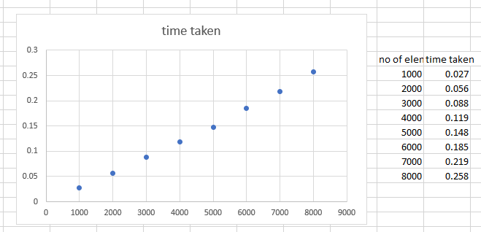

Lab program 2:
Implement Johnson Trotter algorithm to generate permutations.

SOURCE CODE
#include<stdio.h>
#include<time.h>

int main(){
int n,i,a[2000],d[2000];
scanf("%d",&n);

for(i=0;i<n;i++) a[i]=i+1,d[i]=-1;

clock_t t=clock();

while(1){
int m=0,p=-1;

for(i=0;i<n;i++){
int j=i+d[i];
if(j>=0&&j<n&&a[i]>a[j]&&a[i]>m) m=a[i],p=i;
}

if(p==-1) break;

int j=p+d[p],x=a[p]; a[p]=a[j]; a[j]=x;
x=d[p]; d[p]=d[j]; d[j]=x;

for(i=0;i<n;i++) if(a[i]>m) d[i]*=-1;
}

printf("Time: %f",(double)(clock()-t)/CLOCKS_PER_SEC);
}

OUTPUT

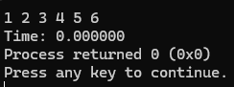

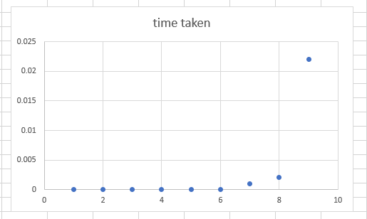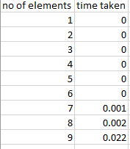

Lab program 3:
Sort a given set of N integer elements using Merge Sort technique and compute its time taken. Run the program for different values of N and record the time taken to sort.

SOURCE CODE
#include <stdio.h>
#include <stdlib.h>
#include <time.h>

int a[5000000],b[5000000];

void merge(int a[],int low,int mid,int high){

int i=low,j=mid+1,k=low;

while(i<=mid && j<=high){
if(a[i]<a[j])
b[k]=a[i++];
else
b[k]=a[j++];
k++;
}
while(i<=mid){
b[k++]=a[i++];
}
while(j<=high){
b[k++]=a[j++];
}
for(int x=low;x<=high;x++)
a[x]=b[x];
}

void merge_sort(int a[],int low,int high){
if(low<high){
int mid=(low+high)/2;
merge_sort(a,low,mid);
merge_sort(a,mid+1,high);
merge(a,low,mid,high);
}
}

int main(){
int n;
printf("\nEnter number of elements: ");
scanf("%d",&n);
printf("\nEntering the elements...");
for(int i=0;i<n;i++){
a[i]=rand()%1000;
printf("%d ",a[i]);
}
clock_t start_time=clock();
merge_sort(a,0,n-1);
clock_t end_time=clock();
printf("\nAfter sorting: ");
for(int i=0;i<n;i++)
printf("%d ",a[i]);
float total_time=(float)(end_time-start_time)/CLOCKS_PER_SEC*1000;
printf("\nTime taken is: %.2f",total_time);
return 0;
}

OUTPUT

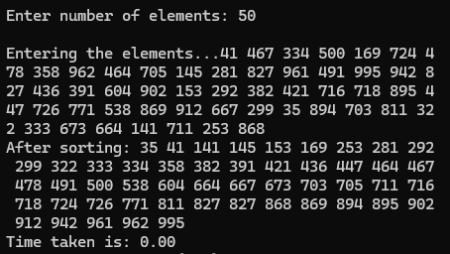

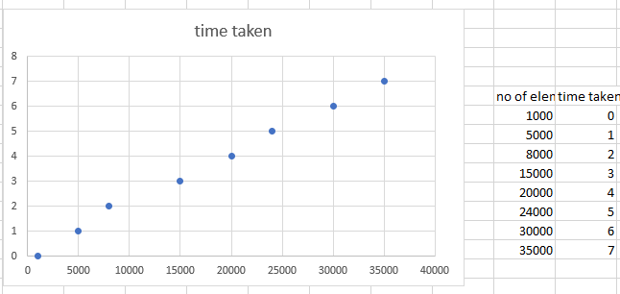

Lab program 4:
Sort a given set of N integer elements using Quick Sort technique and compute its time taken.

SOURCE CODE
#include <stdio.h>
#include <stdlib.h>
#include <time.h>

void exchange(int *a, int *b) {
int temp = *a;
*a = *b;
*b = temp;
}

int partition(int low, int high, int a[]) {
int pivot = a[low];
int i = low + 1;
int j = high;

while (i <= j) {
while (i <= high && a[i] <= pivot) i++;
while (j >= low && a[j] > pivot) j--;
if (i < j) exchange(&a[i], &a[j]);
}
exchange(&a[low], &a[j]);
return j;
}

void quick_sort(int low, int high, int a[]) {
if (low < high) {
int j = partition(low, high, a);
quick_sort(low, j - 1, a);
quick_sort(j + 1, high, a);
}
}

int main() {
int n;
printf("Enter number of elements: ");
scanf("%d", &n);

int a[n];
printf("Unsorted elements:\n");
for (int i = 0; i < n; i++) {
a[i] = rand() % 1000;
printf("%d ", a[i]);
}

clock_t start = clock();
quick_sort(0, n - 1, a);
clock_t end = clock();

double time_taken = (double)(end - start) *1000/ CLOCKS_PER_SEC;

printf("\nSorted elements:\n");
for (int i = 0; i < n; i++)
printf("%d ", a[i]);

printf("\nTime taken: %f seconds\n", time_taken);
return 0;
}

OUTPUT

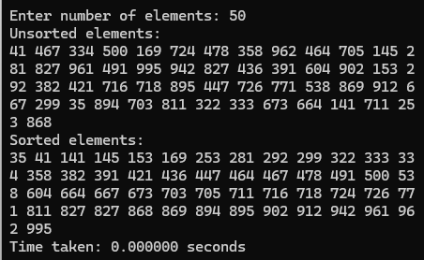

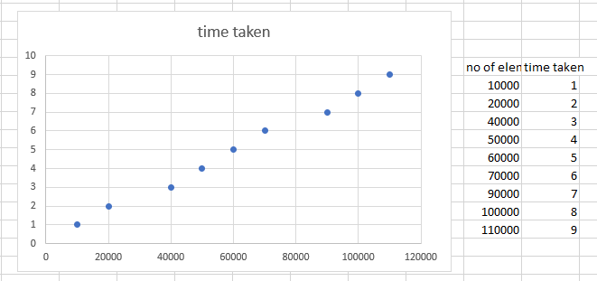

Lab program 5:
Sort a given set of N integer elements using Heap Sort technique and compute its time taken.

SOURCE CODE
#include <stdio.h>
#include <stdlib.h>
#include <time.h>

void heapify(int a[], int n, int i) {
int largest = i, l = 2*i + 1, r = 2*i + 2, temp;

if (l < n && a[l] > a[largest]) largest = l;
if (r < n && a[r] > a[largest]) largest = r;

if (largest != i) {
temp = a[i];
a[i] = a[largest];
a[largest] = temp;

heapify(a, n, largest);
}
}

void heapSort(int a[], int n) {
int i, temp;

for (i = n/2 - 1; i >= 0; i--)
heapify(a, n, i);

for (i = n-1; i > 0; i--) {
temp = a[0];
a[0] = a[i];
a[i] = temp;

heapify(a, i, 0);
}
}

int main() {
int n, i;

printf("Enter number of inputs: ");
scanf("%d", &n);

int a[n];

srand(time(0));

// Generate random numbers
for (i = 0; i < n; i++)
a[i] = rand() % 1000;

clock_t start, end;

start = clock();

heapSort(a, n);

end = clock();

double time_taken = (double)(end - start) / CLOCKS_PER_SEC;

printf("\nSorted elements:\n");
for (i = 0; i < n; i++)
printf("%d ", a[i]);

printf("\n\nExecution Time = %f seconds\n", time_taken);

return 0;
}

OUTPUT

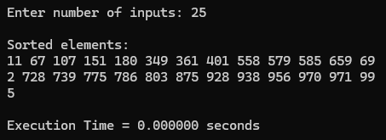

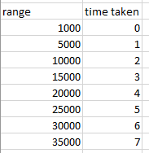

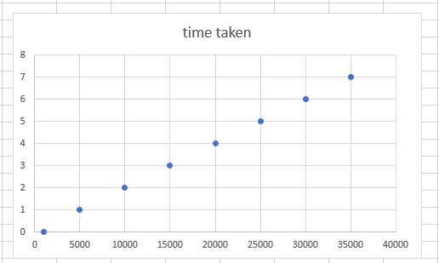

Lab program 6:
Implement 0/1 Knapsack problem using dynamic programming.

SOURCE CODE
#include <stdio.h>
#include <time.h>

#define N 4
#define W 8

int max(int a, int b) {
return (a > b) ? a : b;
}

int main() {
int wt[N] = {3,4,6,5};
int val[N] = {2,3,1,4};

int dp[N+1][W+1];

clock_t start = clock();

for(int i = 0; i <= N; i++) {
for(int w = 0; w <= W; w++) {
if(i == 0 || w == 0)
dp[i][w] = 0;
else if(wt[i-1] <= w)
dp[i][w] = max(val[i-1] + dp[i-1][w - wt[i-1]], dp[i-1][w]);
else
dp[i][w] = dp[i-1][w];
}
}

clock_t end = clock();

printf("Max value = %d\n", dp[N][W]);
printf("Execution time = %lf sec\n", (double)(end - start)/CLOCKS_PER_SEC);

printf("\nDP Matrix:\n");
for(int i = 0; i <= N; i++) {
for(int w = 0; w <= W; w++) {
printf("%3d ", dp[i][w]);
}
printf("\n");
}

return 0;
}

OUTPUT

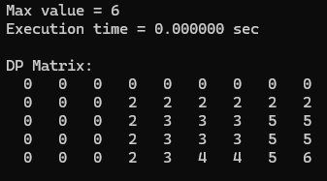

Lab program 7:
Implement All Pair Shortest paths problem using Floyd’s algorithm.

SOURCE CODE
#include <stdio.h>
#include <stdlib.h>
#include <time.h>

int d[100][100], i, j, k,n ;

main() {
srand(time(0));
printf ("ënter n");
scanf("%d",&n);
for (i = 0; i < n; i++){

for (j = 0; j < n; j++){
d[i][j] = i == j ? 0 : rand() % 20000 + 1;
printf("%d ",d[i][j]);
} printf("\n");
}
clock_t s = clock();

for (k = 0; k < n; k++)
for (i = 0; i < n; i++)
for (j = 0; j < n; j++)
if (d[i][k] + d[k][j] < d[i][j])
d[i][j] = d[i][k] + d[k][j];

printf("%f", (double)(clock() - s) / CLOCKS_PER_SEC);
}

OUTPUT

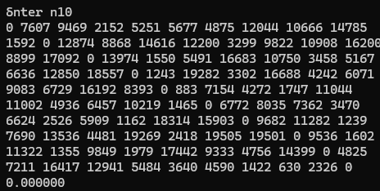

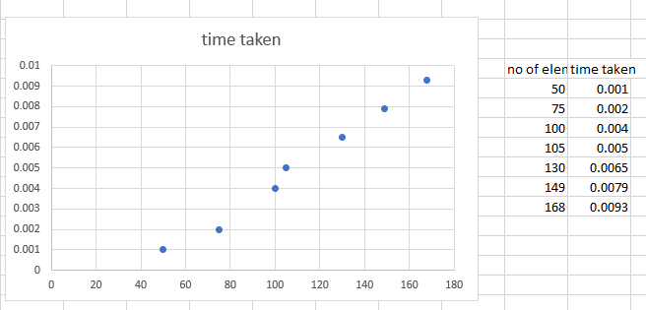

Lab program 8:
- Find Minimum Cost Spanning Tree of a given undirected graph using Prim’s algorithm.
- Find Minimum Cost Spanning Tree of a given undirected graph using Kruskal’s algorithm.

SOURCE CODE
#include <stdio.h>
#include <stdlib.h>
#include <time.h>

#define INF 9999

int parent[100] = {0};

int find(int i){
if(parent[i] == 0)
return i;
return parent[i] = find(parent[i]);
}

int uni(int i,int j){
if(i != j){
parent[j] = i;
return 1;
}
return 0;
}

int main(){
int n,c[100][100],i,j,choice;
clock_t start,end;

printf("Enter number of vertices: ");
scanf("%d",&n);

srand(time(0));

for(i=0;i<n;i++){
for(j=0;j<n;j++){
if(i == j)
c[i][j] = INF;
else{
int w = rand() % 100 + 1;
c[i][j] = c[j][i] = w;
}
}
}

printf("Enter 1 for Prim, 2 for Kruskal: ");
scanf("%d",&choice);

start = clock();

if(choice==1){
int vis[100]={0},min,u,v,a,b,ne=1,total=0;

vis[0]=1;

while(ne < n){
min = INF;

for(i=0;i<n;i++){
if(vis[i]){
for(j=0;j<n;j++){
if(!vis[j] && c[i][j] < min){
min = c[i][j];
a = i;
b = j;
}
}
}
}

total += min;
vis[b] = 1;
ne++;
}

printf("Cost = %d\n", total);
}

else{
int min,u,v,a,b,ne=1,total=0;

while(ne < n){
min = INF;

for(i=0;i<n;i++){
for(j=0;j<n;j++){
if(i != j && c[i][j] < min){
min = c[i][j];
a = u = i;
b = v = j;
}
}
}

u = find(u);
v = find(v);

if(uni(u,v)){
total += min;
ne++;
}

c[a][b] = c[b][a] = INF;
}

printf("Cost = %d\n", total);
}
printf("\nGenerated Cost Matrix:\n");

for(i = 0; i < n; i++){
for(j = 0; j < n; j++){
if(c[i][j] == INF)
printf("INF ");
else
printf("%3d ", c[i][j]);
}
printf("\n");
}eh

end = clock();

double time_taken = (double)(end - start) / CLOCKS_PER_SEC * 1000;
printf("Time = %.3f ms\n", time_taken);

return 0;
}

Output
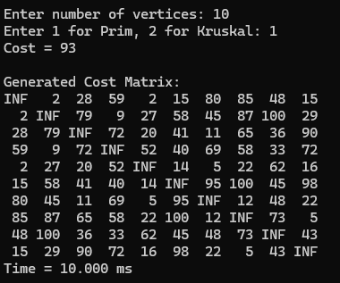
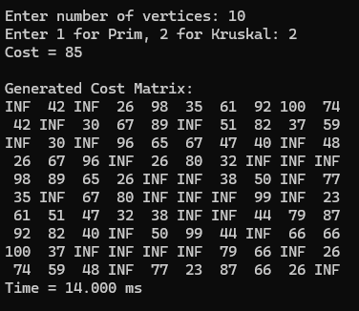

Lab program 9:
Implement Fractional Knapsack using Greedy technique.

SOURCE CODE
#include <stdio.h>

struct Item {
int id;
float profit;
float weight;
float ratio;
};

void heapify(struct Item arr[], int n, int i) {
int largest = i;
int left = 2 * i + 1;
int right = 2 * i + 2;

if (left < n && arr[left].ratio > arr[largest].ratio)
largest = left;

if (right < n && arr[right].ratio > arr[largest].ratio)
largest = right;

if (largest != i) {
struct Item temp = arr[i];
arr[i] = arr[largest];
arr[largest] = temp;
heapify(arr, n, largest);
}
}

void heapSort(struct Item arr[], int n) {

for (int i = n / 2 - 1; i >= 0; i--)
heapify(arr, n, i);

for (int i = n - 1; i > 0; i--) {
struct Item temp = arr[0];
arr[0] = arr[i];
arr[i] = temp;
heapify(arr, i, 0);
}
}

void fractionalKnapsack(int n, struct Item items[], float capacity) {

for (int i = 0; i < n; i++) {
items[i].ratio = items[i].profit / items[i].weight;
}

heapSort(items, n);

float totalProfit = 0.0;
printf("\n--- Selection (Greedy via Heap Sort) ---\n");

for (int i = n - 1; i >= 0; i--) {
if (capacity <= 0) break;

if (items[i].weight <= capacity) {
capacity -= items[i].weight;
totalProfit += items[i].profit;
printf("Added Item %d (100%%). Remaining Capacity: %.2f\n", items[i].id, capacity);
} else {
float fraction = capacity / items[i].weight;
totalProfit += items[i].profit * fraction;
printf("Added Item %d (%.0f%%). Remaining Capacity: 0.00\n", items[i].id, fraction * 100);
capacity = 0;
}
}
printf("\nMaximum Profit: %.2f\n", totalProfit);
}

int main() {
int n;
float capacity;

printf("Enter number of items: ");
scanf("%d", &n);

struct Item items[n];
for (int i = 0; i < n; i++) {
items[i].id = i + 1;
printf("Enter profit and weight for item %d: ", i + 1);
scanf("%f %f", &items[i].profit, &items[i].weight);
}

printf("Enter knapsack capacity: ");
scanf("%f", &capacity);

fractionalKnapsack(n, items, capacity);

return 0;
}

OUTPUT

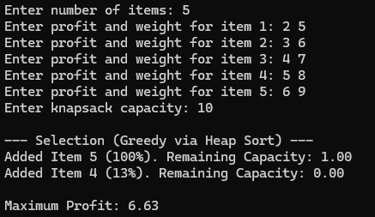

Lab program 10:
From a given vertex in a weighted connected graph, find shortest paths to other vertices using Dijkstra’s algorithm.
SOURCE CODE
#include <stdio.h>
#include <limits.h>

#define V 5
int minDistance(int dist[], int visited[]) {
int min = INT_MAX, min_index;

for (int v = 0; v < V; v++) {
if (!visited[v] && dist[v] <= min) {
min = dist[v];
min_index = v;
}
}
return min_index;
}

void dijkstra(int graph[V][V], int src) {
int dist[V];
int visited[V];

for (int i = 0; i < V; i++) {
dist[i] = INT_MAX;
visited[i] = 0;
}

dist[src] = 0;

for (int count = 0; count < V - 1; count++) {
int u = minDistance(dist, visited);
visited[u] = 1;

for (int v = 0; v < V; v++) {
if (!visited[v] && graph[u][v] &&
dist[u] != INT_MAX &&
dist[u] + graph[u][v] < dist[v]) {

dist[v] = dist[u] + graph[u][v];
}
}
}

printf("Vertex\tDistance from Source\n");
for (int i = 0; i < V; i++) {
printf("%d\t%d\n", i, dist[i]);
}
}

int main() {
int graph[V][V] = {
{0, 10, 0, 30, 100},
{10, 0, 50, 0, 0},
{0, 50, 0, 20, 10},
{30, 0, 20, 0, 60},
{100, 0, 10, 60, 0}
};

int source = 0;
dijkstra(graph, source);

return 0;
}

OUTPUT

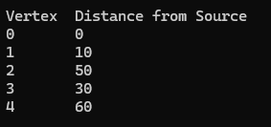

Lab program 10:
Implement “N-Queens Problem” using Backtracking.

SOURCE CODE
#include <stdio.h>
#include <stdlib.h>
int x[20], n;

int place(int k, int i){
for(int j=1; j<k; j++){
if(x[j]==i || abs(x[j]-i)==abs(j-k))
return 0;
}
return 1;
}

void nqueen(int k){
for(int i=1; i<=n; i++){
if(place(k,i)){
x[k]=i;
if(k==n){
printf("\nSolution:\n");
for(int r=1; r<=n; r++){
for(int c=1; c<=n; c++){

if(x[r]==c)
printf("Q ");
else
printf(". ");
}
printf("\n");
}
printf("\n");
}
else
nqueen(k+1);
}
}
}

int main(){

printf("Enter value of n: ");
scanf("%d",&n);

nqueen(1);

return 0;
}

OUTPUT

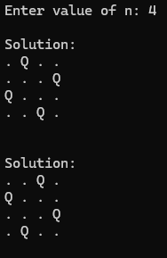

Leetcode 268: Missing Number

int missingNumber(int* nums, int numsSize) {
for (int i = 0; i <= numsSize; i++) {
int f = 0;
for (int j = 0; j < numsSize; j++) {
if (nums[j] == i){
f = 1;
break;
}
}
if (!f) {
return i;
}

}
return 0;
}

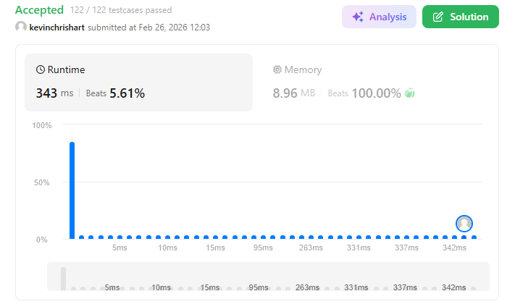

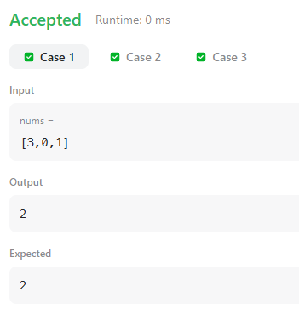

Leetcode 1636: Sort Array By Increasing Frequency

int freq[201];

int cmp(const void* a, const void* b) {
int x = *(int*)a;
int y = *(int*)b;

if (freq[x + 100] == freq[y + 100])
return y - x;
return freq[x + 100] - freq[y + 100];
}

int* frequencySort(int* nums, int numsSize, int* returnSize) {
*returnSize = numsSize;

for (int i = 0; i < 201; i++)
freq[i] = 0;

for (int i = 0; i < numsSize; i++)
freq[nums[i] + 100]++;

qsort(nums, numsSize, sizeof(int), cmp);

return nums;
}

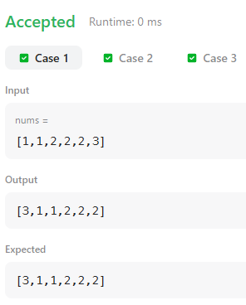

Leetcode 561: Array Partition

#include <stdlib.h>

int compare(const void *a, const void *b) {
return (*(int*)a - *(int*)b);
}

int arrayPairSum(int* nums, int numsSize) {
qsort(nums, numsSize, sizeof(int), compare);

int sum = 0;

for (int i = 0; i < numsSize; i += 2) {
sum += nums[i];
}

return sum;
}
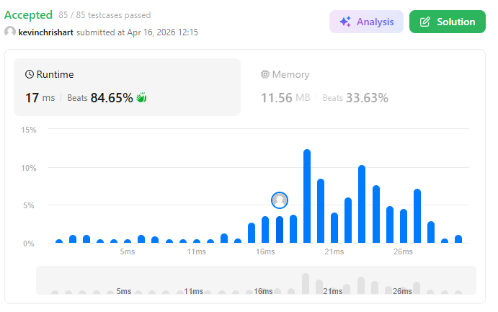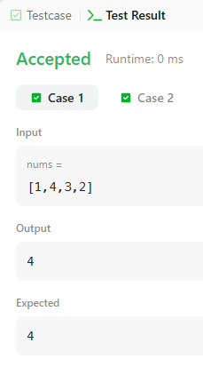

Leetcode 3742: Maximum Path Scored in a Grid

int max(int a, int b){ return a > b ? a : b; }
int maxPathScore(int** g, int m, int* colSize, int k) {
int n = colSize[0];
static int dp[201][201][1001];
for(int i=0;i<m;i++)
for(int j=0;j<n;j++)
for(int c=0;c<=k;c++)
dp[i][j][c] = -1e9;
int cost = g[0][0] ? 1 : 0;
if(cost <= k) dp[0][0][cost] = g[0][0];
for(int i=0;i<m;i++){
for(int j=0;j<n;j++){
for(int c=0;c<=k;c++){
if(dp[i][j][c] < 0) continue;
if(i+1 < m){
int nc = c + (g[i+1][j] ? 1 : 0);
if(nc <= k)
dp[i+1][j][nc] = max(dp[i+1][j][nc], dp[i][j][c] + g[i+1][j]);
}
if(j+1 < n){
int nc = c + (g[i][j+1] ? 1 : 0);
if(nc <= k)
dp[i][j+1][nc] = max(dp[i][j+1][nc], dp[i][j][c] + g[i][j+1]);
}
}
}
}
int ans = -1;
for(int c=0;c<=k;c++)
ans = max(ans, dp[m-1][n-1][c]);
return ans < 0 ? -1 : ans;
}

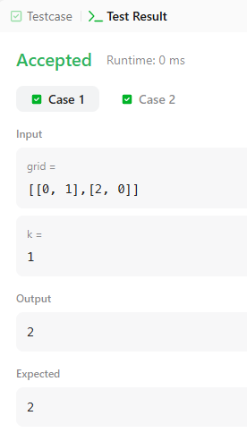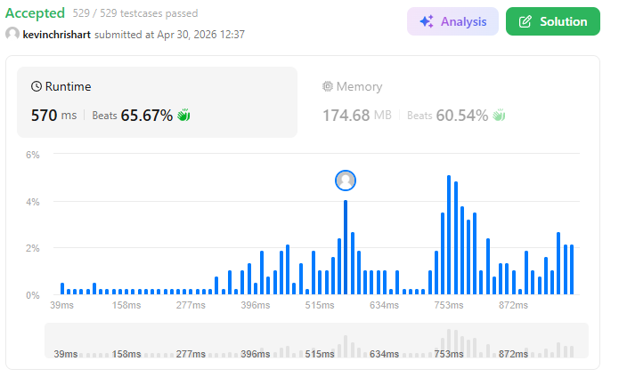

Leetcode 1557: Minimum Number of Vertices to Reach All Nodes

int* findSmallestSetOfVertices(int n, int** edges, int edgesSize, int* edgesColSize, int* returnSize) {
int *indeg = (int*)calloc(n, sizeof(int));
int *res = (int*)malloc(n * sizeof(int));

for(int i = 0; i < edgesSize; i++)
indeg[edges[i][1]]++;

int k = 0;
for(int i = 0; i < n; i++)
if(indeg[i] == 0)
res[k++] = i;

*returnSize = k;
return res;
}

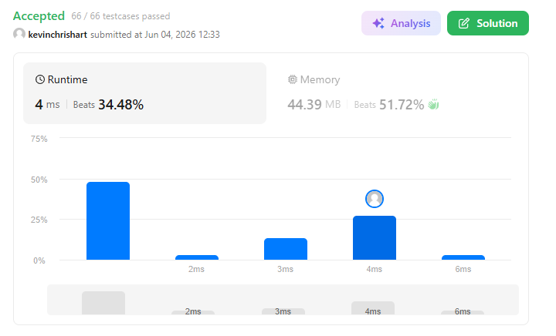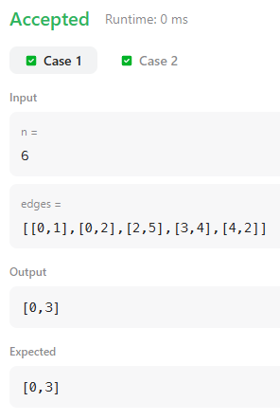

Leetcode 70: Climbing Stairs

int climbStairs(int n) {
if(n<=2) return n;
int a =1;
int b =2;
for(int i=3 ; i<= n ; i++)
{int c = a+b;
a=b;
b=c;
}
return b;
}

